**Design and deploy a scalable network architecture using AWS Transit Gateway to simplify network connectivity between multiple VPCs. Configure VPC endpoints to securely access AWS services without internet gateways or NAT gateways, ensuring data privacy and minimizing exposure to external threats.**

🡪Create transist gate way with name

* Go to, transist gate way attachment 🡪 create attachment
* Name the attachment as region which you r using
* Transist gate way id ( id which you r created in transist gate create)
* 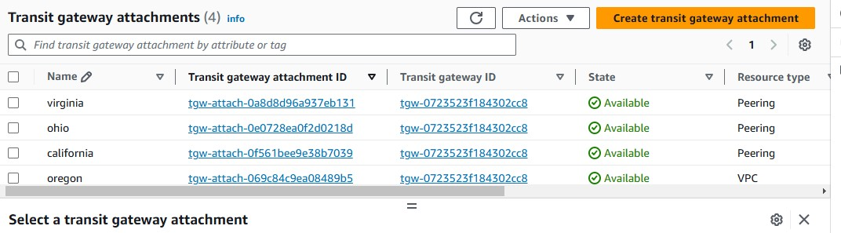Attachment type should be peering connection

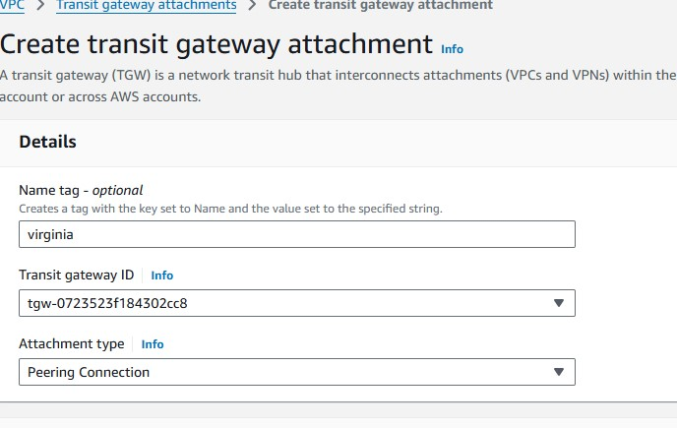

## 🡪Peering connection attachment

* Account should be my account 🡪 select region that you created a vpc in another region 🡪transist gate way id as accepter 🡪 create a attachment
* Same do for other regions with same process

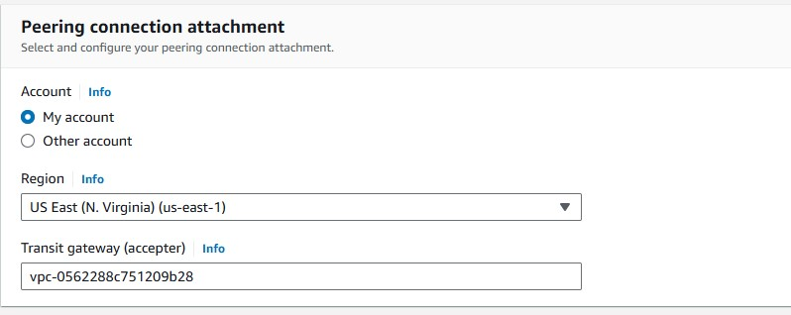

* Go to, transist gate way route table 🡪 click the region that showing 🡪 on below there is a route table available 🡪 click the route 🡪 scroll down, click create static route
* Add all vpc CIDR in transist gate way route table one by one.

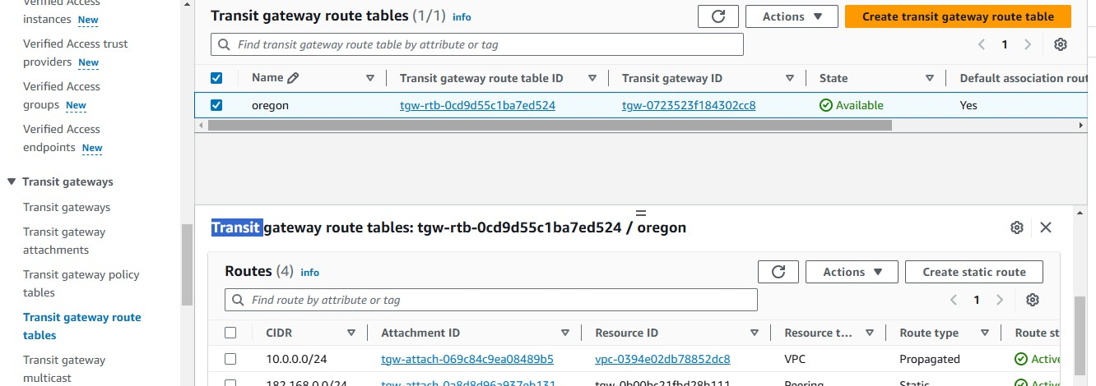

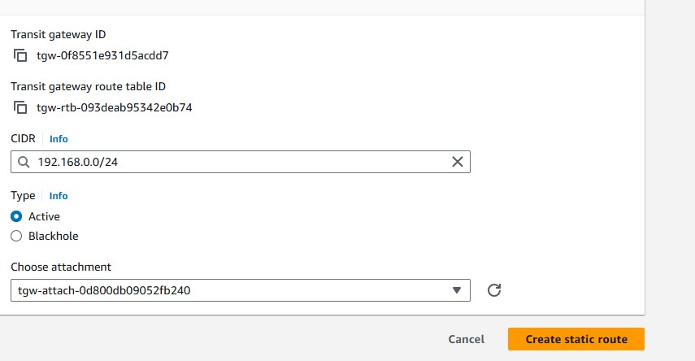

* Same do for other vpc’s with same process
* Go to, route tables 🡪 add all vpc CIDR in route tables in public subnet 🡪 add internet gate way for all vpc’s.

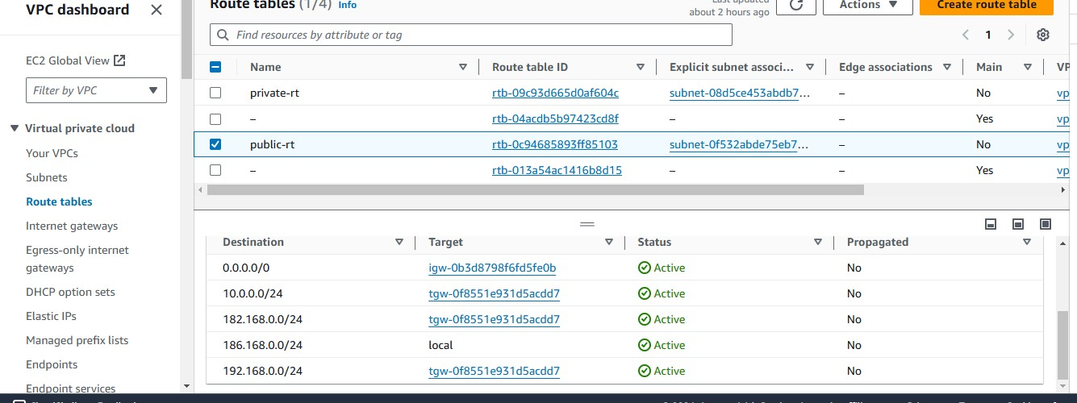

* Same process do add all vpc’s CIDR in route table and add internet gate way

**Create instances with public subnet with different regions to check the connectivity.**

* **Now ping with another instance private ip to check the connectivity**